**北京师范大学广州实验学校**

学校： 班级： 姓名： 学号：

**2019学年第一学期初一年级9月阶段检测英语试题**

命题：初一英语组 审题：肖瑶瑶，覃娇蓉

本试卷共9页，八大题， 满分110分 考试用时90分钟

**一、听力测试(共15分,每题1分)**

**第一节**

**听下面一段对话,回答1-2两个小题。**

（ ）1. Where does Mary come from?

A. Japan. B. Canada C. America

( ) 2. How old is Mary?

A.Twelve B. Thirteen C. Fourteen

**听下面一段独白，回答第3-5三个小题。**

（ ）3. How do Emma and Elsa go to school?

A. By bus B. By bike C. By car

( ) 4. What do Emma and Elsa both like?

1. Listening to pop music and flying kites
2. Listening to pop music and reading books.
3. Reading books and flying kites.

( ) 5. Which of the following is TRUE about Alice?

1. She has long, blonde hair. B.She is a good listener.

C.She is in the same class as Emma and Elsa.

**听下面一段对话，回答第6-7两个小题**。

（ ）6. What is Tom’s favourite sport?

A.Basketball B. Ping-pong C. Soccer

( ) 7. What does Kate think of soccer?

A. Boring B. Difficult C. Easy

**听下面一段独白，回答第8-10三个小题**

（ ）8. Where does Mike live now?

A. In New York B. In Beijing C. In Ottawa.

( ) 9. How many people are there in Mike’s family?

A. Five B. Six C. Seven

( ) 10. What is Mike’s favorite subject?

A. PE. B. English C. Maths



**回答问题。（每空一词，每题1分）**

**听下面一段独白，回答以下两个问题。**

What does Wang Lin’s father do? ----He is （11） _____ （12）__________.  
What is Wang Lin’s brother’s hobby? -----His hobby is（13） _____ （14）______ （15）__________.

**二、单词辨音（选出划线部分读音不同的一项，共5分，每题1分）**

16.( )A.German B.grammar C.Japan D.flat

17.( )A. able B. face C. back D. name

18.( )A. hope B. half C. hour D. hobby

19. ( )A. century B. bed C. letter D. toilet

20.( )A. cook B. shoot C. goose D. tooth

**三、单项选择（共10分，每题1分）**

21. They would like ______ their grandparents on Saturday.

A. visit B. visiting C. to visit D. visits

22. I hope everyone______ our English party.

A. to come to B. come to C. to come D. can come to

23. ——_____ country dose your e-friend come from?

——_____. She is a beautiful girl.

A. Which;German B.Which;Germany

C. Where;German D.Where;Germany

24. ——_____did you stop playing?

—— Because I was tired.

A. How B. Why C. When D. Where

1. Look! There is _____useful book on the table.

A. a B. an C. the D. /

1. ——I like eggs and bread for_____breakfast.

——Me, too. I always have them with_____cup of milk.

A. a;a B. the;a C. /;the D. /;a

1. ——______.

——He is tall and has two big eyes.

A. How is your friend?

B. What does your friend do?

C. What does your friend look like?

D. What does your friend like?

1. There are_____people in the room.

A. much B. lot of C. a lots of D. lots of

1. I_____late. I always go to school on time.

A. am always B. always am C. am seldom D. seldom am

1. Do you enjoy_____books?

A. read B. reading C. see D. seeing

四、完型填空**（共10分，每小题1分）**

Peter and John are good friends. They often have the___31___ experience. One day, Peter hurt his right arm when he played football. Three days later, John hurt his right ___32___too.

“We’re cool, right?" said Peter.

The first week was ___33___. Peter and John needn't ___34___ in P.E. class. They needn't do their ___35___ because they couldn't write. The second week they ___36___ it was not so good. They had to do all things with just one arm and that was___37___. John couldn't fish. Peter couldn’t___38___computer games. The third week they felt depressed (沮丧的) because they couldn't swim when they and their classmates went to the___39___. They had to watch others___40___.

Peter said to John,“I hope our arms can recover (康复) soon.”

( )31.A.same B. different C.new D. old

( )32. A. leg B. arm C. foot D. eye

( )33. A. busy B. quiet C. hot D. nice

( )34. A. sing B. draw C. eat D. run

( )35. A. housework B. homework C. hobby D. dream

( )36. A. heard B. knew C. found D. saw

( )37.A.funny B. boring C. important D. hard

( )38. A. play B. make C. complete D. send

( )39. A. farm B. ZOO C. beach D. forest

( )40. A. eat out B. get lost C. have fun D. call back

**五、阅读理解 （共 40分，每小题2分）**

A

|  |  |
| --- | --- |
| [21世纪教育网 -- 中国最大型、最专业的中小学教育资源门户网站](http://www.21cnjy.com/) | Hi, I am [Sandra](http://www.21cnjy.com). I am thirteen years old. I like singing, so I have music classes every weekend. I don't have to study on weekends because I do well in all my subjects. On Sunday I often help my grandmother with her housework. |
| [21世纪教育网 -- 中国最大型、最专业的中小学教育资源门户网站](http://www.21cnjy.com/) | My name's Hen[ry. I](http://www.21cnjy.com) am twelve years old. On Saturday, my father teaches me to learn Maths at home for two hours in the morning. On Sunday, I always stay at home to do my homework. I have much homework to do. I hope not to be so busy, but my mother always says I have to study well |
| [21世纪教育网 -- 中国最大型、最专业的中小学教育资源门户网站](http://www.21cnjy.com/) | I am Betty. I a[m thir](http://www.21cnjy.com)teen years old. On Saturday, I usually do my homework. I am free on Sunday, so I can do everything I like. I often meet my friend. Sometimes we go to the movies. Sometimes we go to the library for reading. We have a good time. But If it rains, I have to stay at home and I feel bored. |

( ) 41. Why does Sandra NOT need to study on weekends?【来源：21·世纪·教

A. Because she is busy with her music classes.21·世纪*教育网

B. Because she is good at her subjects.

C. Because she has to help her grandmother do the housework.【来源：21cnj*y

D. Because she doesn't like to study on weekends.

( ) 42. [From](http://www.21cnjy.com) the passage, we can know Henry's father is good at ______.

A. History B English C. Geography D. Maths

( ) 43. Which of the following about Betty is TRUE?【版权所有：21教育】

A. She doesn't have to do her homework on Saturday.

B. She can do everything she likes on Sunday.

C. She seldom has a good time on Sunday.

D. She likes rain on Sunday very much.

( ) 44. Who is the most hard-working（勤奋的） of the three students on weekends?

A. Sandra. B. Betty. C. Henry. D. No one.

( ) 45. The passage mainly tells us _____.

A. the daily life of the three students on weekends

B. the study of the three students

C. what the three students like to do on weekends

D. what classes the three students have on weekends

B

Dear Star,

Thank you so much for your letter -- I am so glad we are going to be pen friends. I am very interested in finding out all about life in Hong Kong. I can't imagine what it is like.

I expect you will want to know about my life in England, so let me tell you a little about myself. I live with my mum and dad and two brothers, Colin and Robert, who are both younger than me. I am 14 years old and I am in my third year at Bramhall Comprehensive School. The school is quite far from my house, so I have to take a bus each morning. My hobby is swimming (I am on the school swimming team). I also like playing with my dog, Ralph. I'm not sure what else I will tell you. Maybe when you write to me next time, you could ask me some questions, and don't forget to tell me all about yourself as well!

Your pen friend,

Kristy

( ) 46. Kristy and Star are going to be _.

A. sisters B. pen friends C. cousins D. students

( ) 47. How many people are there in Kristy's family?

A. Two. B. Five. C. Six. D. seven

( ) 48. Kristy is interested in_ .

(1) life in Hong Kong (2) writing

(3) swimming (4) playing with the dog, Ralph

A. (1) B. (1)(2)(3)(4) C. (1)(3)(4) D. (2)(3)(4)

( ) 49. Kristy is _ her brothers.

A. older than B. the same age as C. younger than D. happier than

( ) 50. Which of the following statements is NOT true according to the passage?

A. Kristy has never been to Hong Kong.

B. Kristy's pet is a dog.

C. Kristy's school is far from her house.

D. Kristy has a lot to tell Star, but she hasn't got much time.

C

Are you the only child in your family? How do you feel if you have a little brother or sister? Having a new baby in your family is really great. If everyone in the family helps to take care of the baby, then it will be very happy to be part of such a family.

If you are old enough, you may be able to help your mum or dad look after the baby. You can hold the baby, help to bath it, or walk it around the house or garden. But you should always ask Mum or Dad before you do anything for the baby. Your mum is likely to be very tired if the new baby wakes a lot during the night. You might be able to help your mum by doing something nice for her.

You may feel a little jealous of the baby at times. Don't think that you are a bad kid if you get those feelings. It is very normal (正常的) for any kids to have such feelings.

( ) 51. Having a new baby in a family is really________.

A. boring B. relaxing C. great D. sad

( ) 52 The underlined word "jealous" means “________ ” in Chinese.

A.高兴的 B．伤心的 C．嫉妒的 D．傲慢的

( ) 53. If you are old enough, you can________.

A. hold the baby B. help to bath it

C. walk it around the house or garden D. A, B&C

( ) 54. Which of the following is NOT true?

A. You should always ask Mum or Dad before you do anything for the baby.

B. Your mum is likely to be very tired if the new baby wakes a lot during the

night.

C. If you feel jealous, you are a bad kid.

D. If everyone in the family helps to take care of the baby, it will be very happy

to be part of such a family.

( ) 55. The best title of the passage is“________”.

A. The only child in the family B. Helping parents with housework

C. Having a new baby in the family D. How to look after yourself

**D**

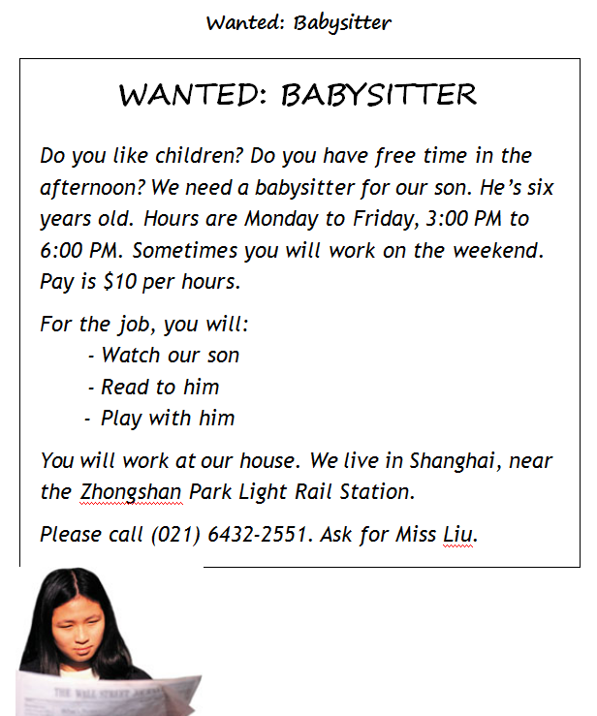

1. On Friday, the babysitter will __________.

A. not work B. work three hours

C. earn $10 D. live in Shanghai

1. What is not part of the job?

A. Cooking for the child. B. Working at the child’s house.

C. Reading books to the child. D. Taking care of the child.

58. The babysitter must __________.

A. go to the person’s office B. drive a car to work

C. work every Saturday and Sunday D. play with the child

59. Which of these sentences is TRUE?

* 1. Pay is more on weekends.
  2. The babysitter must work six days a week.
  3. The person must first call Mr. Liu.
  4. The child is less than nine years old.

60. The best babysitter for the job __________.

A. cannot read story books B. is busy on Wednesday afternoon

C. wants $15 per hour D. enjoy playing with children

**六、写作（共3节，满分30分）**

**第一节 单词拼写 （共6小题，6分，每小题1分。）**

61. Mike lives near some m_________. There are a large number of trees around.

62. I c________ my homework and then went shopping with my mom last Saturday.

63. The Physics(物理) teacher said, ‘Light travels more quickly than s________.’

64. I can speak English well, but I am not good at English g________.

65. Students can have a b________ between two lessons.

66. We enjoy our d________ life here, because we have so many activities every day.

**第二节 完成句子（共7小题，每小题2分，每空一词，共14分）**

67. 西蒙的爸爸通常坐公共汽车去上班。

Simon’s father usually _______ _______ _______ to go to work.

68. 我的朋友鲍勃和我都很擅长打篮球和游泳。

My friend Bob and I _______ _______ _______ _______ basketball and swimming.

69. 我愿意成为你的笔友。

_______ _______ _______ _______ your pen pal.

70. 你的妈妈是做什么工作的？

_______ _______ your mother_______?

71. 我希望每周都收到我的笔友的来信。

I _______ _______ _______ _______ my pen pal every week.

72. 我的父亲小时候的梦想就是成为一名工程师。

My father’s _______ _______ _______ _______ an engineer when he was a child.

73. 男生们空闲的时候喜欢在一起打电脑游戏。

Boys like playing computer games together _______ _______ _______ _______.

1. **书面表达 （共1题，10分）**

假期就要来临，你德国的好友John给你发来问候的邮件，信中透露愿意跟你的同学小明交友，想了解小明的一些基本情况(年龄、外貌、爱好、兴趣、住址、家庭等)，并表示国庆节（National Day）想来中国和你们一起玩。现在请你针对他的来信内容，回复他的邮件，对他来中国表示欢迎，并简单介绍你们平时的活动安排。

**要求：80字左右，注意人称和时态。开头和结尾已经给出，不计字数。**

Dear John:

Glad to hear from you! ____________________________________________________

___________________________________________________________________________

___________________________________________________________________________

___________________________________________________________________________

___________________________________________________________________________

___________________________________________________________________________

___________________________________________________________________________

I can’t wait to see you.

Best wishes,

Bobby